The communication cycle is a theoretical concept that illustrates the process of communication between a sender and a receiver. It involves several key elements that contribute to the exchange of information. Here's a brief note on the communication cycle:
The communication cycle starts with a sender, who has a message to convey. The sender encodes the message into symbols, whether spoken, written, or non-verbal, based on a shared understanding of language and symbols. The process of converting the abstract ideas of the sender into understandable forms is defined as ENCODING.
The next stage involves the transmission of the message. This can happen through various channels. The physical or digital pathway of the message is CHANNEL . The channel depends on the nature of the message and the preferences of the sender. The tools employed for creating the message like languages, colors, codes, symbols, maps, charts, signs, charts, graphs etc. are the MEDIUM of communication.
The receiver then decodes the message, translating the symbols back into understandable information. Successful communication occurs when the receiver interprets the message in a way close to the sender's intended meaning.

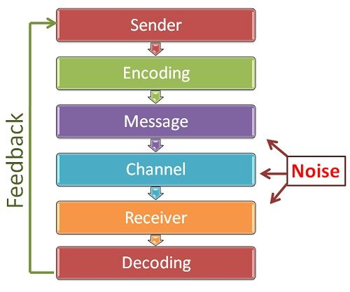

Key Characteristics (Features) of Communication
- Two-Way Process: It relies on both transmission and a return response (feedback) from the receiver to complete the loop.
- Minimum of Two Parties: It requires at least a sender to start the message and a receiver to receive it.
- Continuous and Dynamic: It is often an ongoing cycle rather than a one-time static event.
- Goal-Oriented: Its primary objective is to create shared understanding and prompt a specific reaction or behavior.
- Pervasive: It happens across all levels, departments, and functions of any organization or social group.
- Multiform: It can be expressed through verbal (oral, written) or non-verbal channels (body language, gestures, signs).
- One cannot not communicate.

Feedback is a crucial element in the communication cycle. After receiving the message, the receiver provides feedback to the sender. This feedback can be verbal, non-verbal, or written, and it helps the sender understand how well the message was received and interpreted.
Feedback plays a crucial role in the communication process, as it marks the end of one cycle of communication and the beginning of the next cycle of communication.
Types of feedback
- Positive and Negative feedback ( based on the content)
- Immediate and Delayed feedback ( based on the time involved)
- Deliberate positive and Deliberate Negative (based on the underlying intention of the feedback)
- Deceptive Feedback (based on the apparent and implied meaning of the feedback)

Noise or barriers in communication can disrupt the cycle. These may include physical noise, language barriers, psychological factors, or distractions that affect the clarity and effectiveness of the message.
Barriers are segmented as:
Physical/ environmental barriers to communication
Physiological/ biological barriers to communication
Psychological barriers to communication
Mechanical/technological/ technical barriers to communication
Linguistic Barriers to communication
Socio-cultural barriers to communication
Effective communication involves a continuous cycle of encoding, transmission, decoding, and feedback. It is dynamic and influenced by the context, the relationship between the sender and receiver, and the feedback loop, allowing for adjustments and improvements in subsequent communication.

